How to Borrow a Book

from your

Technology Learning Commons (TLC)

by Placing a Hold

(for in-school students only)

- Begin by going to http://www.CastlebrookeTLC.ca and click on Catalogue.

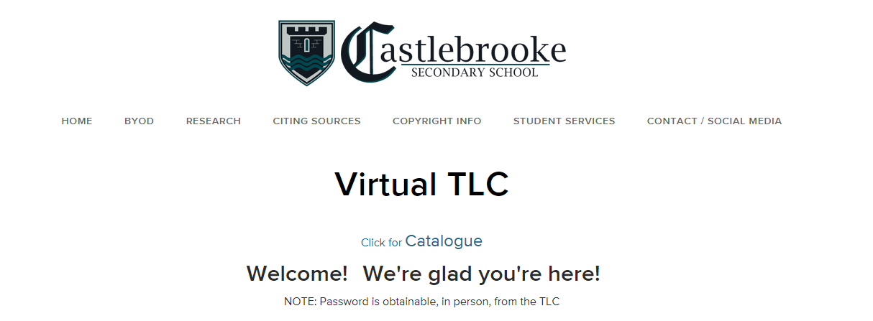

- In the search bar, type in the name of the text you are searching for.

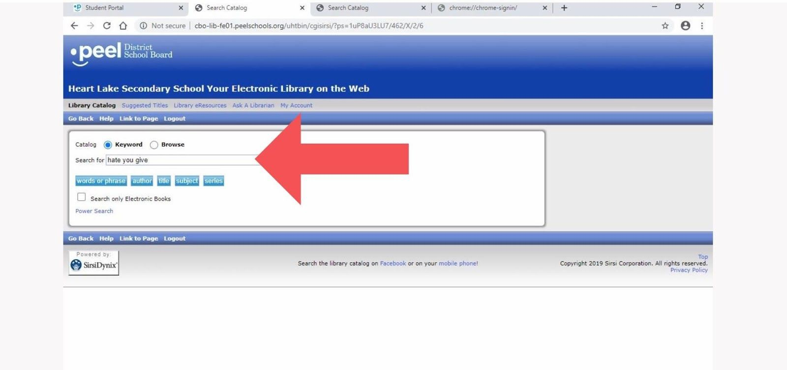
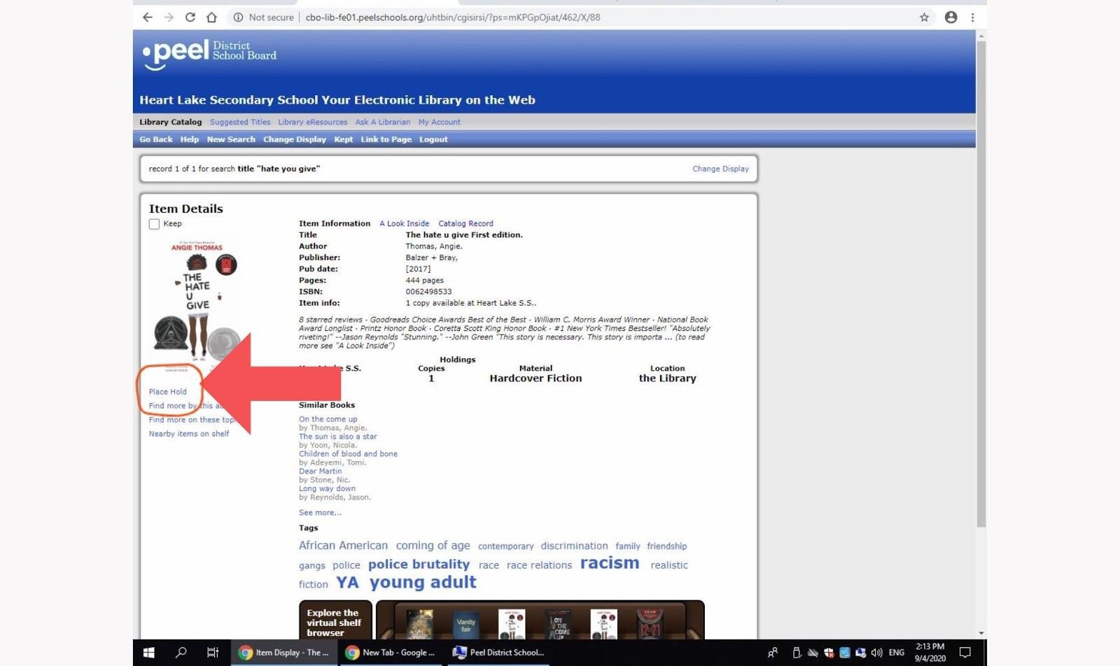
- When the search comes up, click on the title you wish to place on hold. Once this window opens, click on the ‘place hold’ text on the screen.

- Enter your student number in the user I.D. field, then click on the place hold button. You may place up to three items on hold at a time.

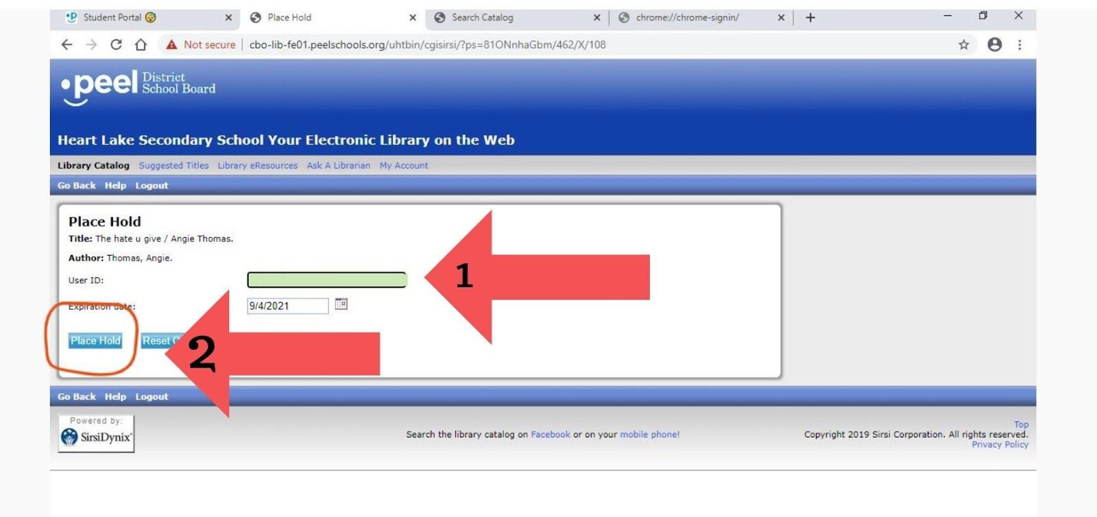

- Your item has been placed on hold. Congratulations

- In 1-2 working day, you will receive an e-mail in your pdsb.net account from Ms. Park with details on how and where you pick-up your reserved items.

In the email will be a reminder of when the item is due and how it is to be returned.

Thanks for placing a hold!.
